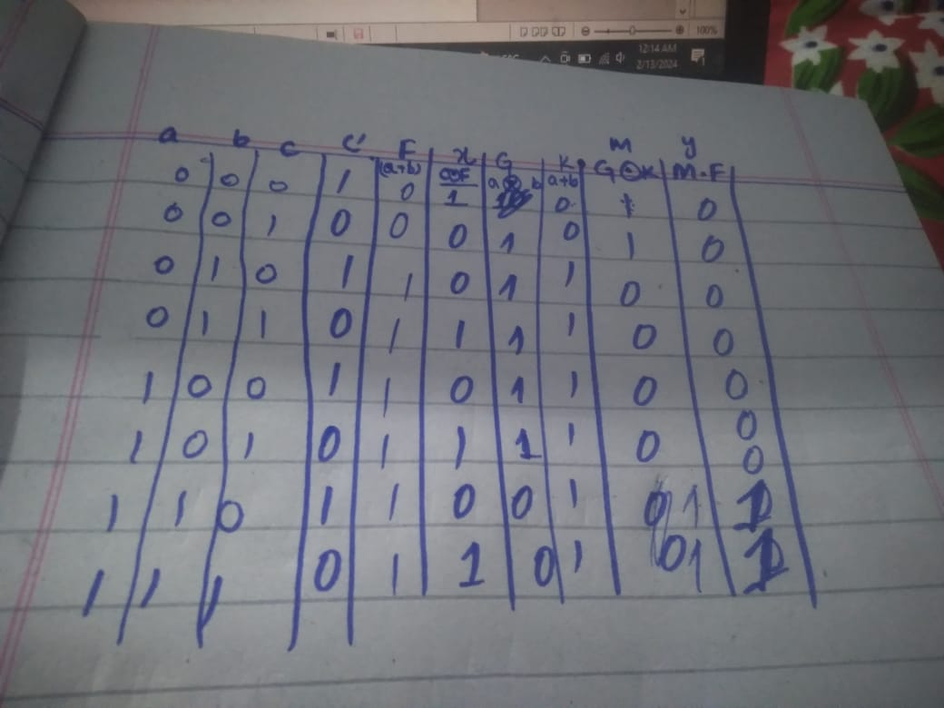
Errror:
in line 5 , assign is not used
in line 6 , & operatin is not used between c and (a^b)
Error
in line 18,24,30 a1,b1,c1 are not correctly used.
And in lasr lines end, initial , begin are not used.

(c) Corrected codes
Listing 4
module full_adder(
input logic a,
input logic b,
input logic c,
output logic sum,
output logic carry
);
assign sum = (a ^ b) ^ c;
assign carry = (a & b) | (c&(a ^ b));
endmodule
Listing 5
module full_adder_tb();
logic a1;
logic b1;
logic c1;
logic sum1;
logic carry1;
full_adder uut(
.a(a1),
.b(b1),
.c(c1),
.sum(sum1),
.carry(carry1)
);
initial
begin
// Provide different combinations of the inputs to check validity of code
a1 = 0; b1 = 0; c1 = 0;
#10;
a1 = 0; b1 = 0; c1 = 1;
#10;
a1 = 0; b1 = 1; c1 = 0;
#10;
a1 = 0; b1 = 1; c1 = 1;
#10;
a1 = 1; b1 = 0; c1 = 0;
#10;
a1 = 1; b1 = 0; c1 = 1;
#10;
a1 = 1; b1 = 1; c1 = 0;
#10
a1 = 1; b1 = 1; c1 = 1;
#10;
$stop;
end
endmodule

https://github.com/abdullahrasheed126/dsd-lab

